

In:Site 2018
Graduate Maker/Artists’ Brief

Introduction

In:Site is an annual festival of graduate contemporary craft featuring emerging makers/artists. Taking place in Cathedral Square, Birmingham, the festival is distinctive in commissioning new graduates to develop, define and reflect on site-specific and/or socially engaged craft practice in a public setting. In this context, socially engaged practice means a collaborative engagement with the public for artistic outcomes and may also include social outcomes. Site-specific is defined as responding to one or more of the following areas: geographical, historical, social and cultural aspects of the space/place.

What are we looking for graduate makers/artists to do?

In:Site 2018 is exploring the connections between the historic and contemporary. We are looking for graduate makers/artists to create works inspired by the historical and contemporary life of the square, linking people, place and heritage.

The site celebrated its tercentenary year in 2015 reflecting on Birmingham as a town that became a city and its social, cultural and industrial heritage. The Square (churchyard) and Cathedral have hardly changed during 300 years whilst the area around has evolved and developed enormously. Today a network of pathways through this green space leads to the business district, city centre retail and cultural areas. A diverse public of approximately 20,000 people pass through each day. Proposals may respond directly to heritage stories within or around the Square or could explore broader questions about the site inspired by the historical, geographical, social, cultural aspects.

Over one day each maker/artist will create an outdoor installation, engaging a transitory audience in their work. Public engagement varies from watching or experiencing the making process to participating in making activity.

When and Where?

- The festival takes place during Monday 3rd to Friday 7th September 2018. Installations will be in situ over the weekend until 10th September 2018.
- Makers/artists will be allocated one day during the week to create their installation in Cathedral Square, Birmingham.
- The installations created are on show for the duration of the festival. Please note that this space is not monitored by staff outside of festival hours and is accessible to the public 24 hours a day. The work made is temporary and may not be returnable to the maker.

Who are we looking for?

We are looking for Graduate Makers/Artists who:
- Will be undergraduates finishing in summer 2018 or have successfully completed their post-graduate in autumn 2017.
- Have studied applied arts and craft and are committed to and focussed on developing their craft and applied arts practice
- Are enthusiastic, innovative and creative in response to the brief
- Are willing to explore new ideas
- Clearly articulate how they will engage with the public and respond to the site.
- Are interested in challenging themselves and their practice, exploring ways of engaging the public in contemporary craft through their own work
- Will briefly be filmed talking about the making of their work at In:Site
- Will liaise effectively with Craftspace to be briefed about and work towards the event
- Will adhere to health and safety requirements and Craftspace’s codes of conduct about engaging with staff, partners and the public
- Will complete an evaluation form reflecting on their participation at In:Site
- Will follow and adhere to the Rules of Intervention (see attached document)
- We welcome applications from graduates who consider themselves disabled and will make reasonable adjustments to enable them to fulfil the brief.

Craftspace will:
- Cover travel costs and limited materials budget
- Pay a fee of £150
- Offer advice and career guidance whilst on-site
- Provide guidance on working with the public and creating work in a public setting
- Recruit and brief volunteers to support makers/artists during the making of their work
- Manage and promote the festival and liaise with relevant organisations and authorities about the installations and activities in the square during In:Site 2017

Application Procedure
Makers/artists must read the background information and complete application proposal forms available at www.craftspace.co.uk from Tuesday 7th June.

Applications close 5pm on Sunday 15th July


In:Site 2018
Application Information

Rules for Interventions

The Cathedral and grounds are a heritage site and any activity within the area must consider and respect this status, therefore the following rules must be strictly adhered to whilst working within the grounds.

- No sharp objects to be inserted into the ground (i.e. no tent pegs), sufficient alternative methods must be used. The grassed area has a sprinkler system that is automatically activated at 8am each day and therefore any sharp object(s) inserted into the ground would cause damage.
- The grounds must be left as they are found (excluding the intervention). All surplus materials (waste) from activities must be collected and disposed of appropriately. The grass is cut each day and any materials left on the ground will cause problems for the lawn mowers. In certain circumstances it may be preferable to work on tarpaulin to ensure small bits of materials (such as wire) are contained.
- Any interventions attached to any static fixture (railings, benches, trees etc.) must be securely fastened with temporary fixings (i.e. cable ties, string etc.). No permanent fixings such as glues and strong adhesive tapes are to be used under any circumstances.
- All pathways must be kept clear and provide no obstructions.
- All intervention ideas have to be discussed and approved by Craftspace. The artist will be informed if any modification to their ideas is required.
- To ensure you have sufficient information on the project and area (in addition to the project brief) for your context led intervention, please refer to the links provided below.
- The installations are temporary and created in a space accessible to the public 24 hours a day. There is CCTV monitoring in the area but in the event of any damage, theft or loss of installations created during the festival, Craftspace and Birmingham Cathedral cannot be held responsible.

Images of the Square
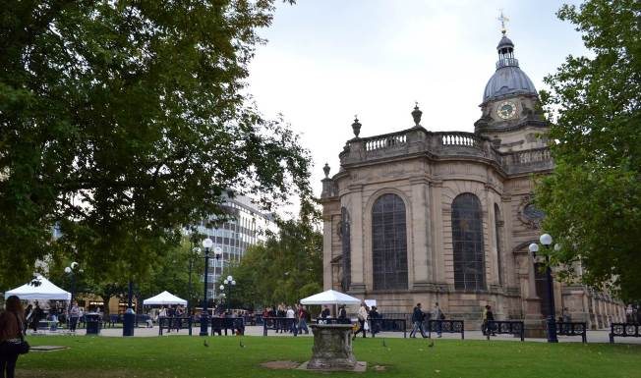
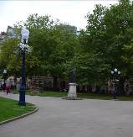
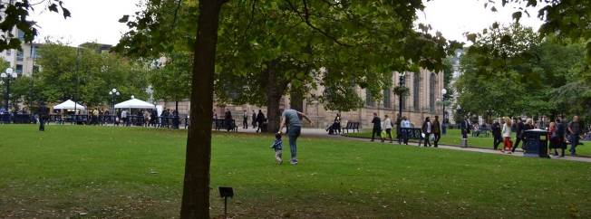
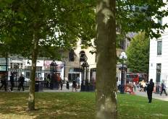
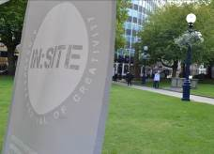

Historical Images of the Town and Square

The following four images section are shown with kind permission from Birmingham Cathedral

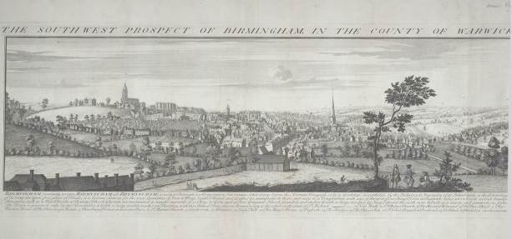

The South West Prospect of St Philip’s Birmingham 18th Century

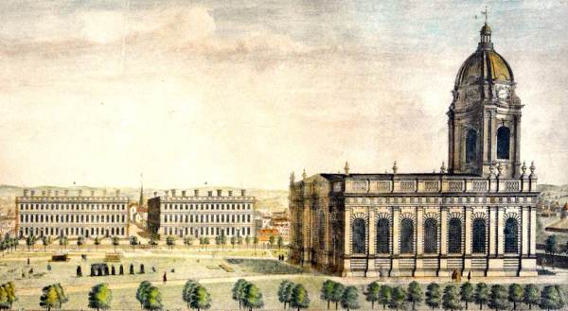

The North Prospect of St Philip’s 18th Century by Robert Jones

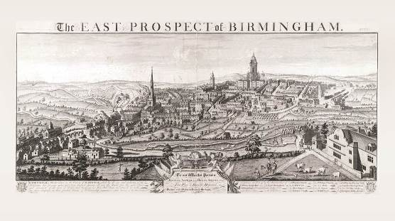
The East Prospect of St Philip’s Church 18th Century

Engraving of St Philip’s Church

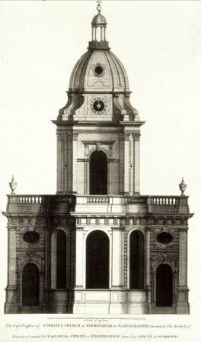

History of Square

The text below is quoted from http://www.birminghamcathedral.com/cathedralsquare/
The early churchyard was enclosed by a stone wall on three of its sides, and from an early date there were paths running around the perimeter and across the churchyard. Although the churchyard is now much reduced in size in the early C18th, a rectory was built on the corner of Temple Row and St Philip’s place and the Blue Coat School on the corner of St Philip’s Place and Colmore Row. There were grand three storey homes on Temple Row. Although not originally planned as a square the area around St Philip’s was developed with an eye to enhancing and preserving its attractive qualities.

- Thought to be around 60,000 burials in the churchyard.
- In 1858 the burial ground was closed to further burials, conditions were very poor and potentially a threat to public health
- There are about 100 monuments left visible.
- Very occasionally new ones are added to mark a person or event of significance, most notably there is a memorial to all 21 who died in the 1974 Birmingham pub bombings and it was erected in 1995.

Listed monuments in the churchyard include:
    - The Samuel Lines monument to the founder of the Royal Birmingham School of Art and artist in his own right The Unett Monument to an important soldier who fought at Sebastapool
    - The Burnaby Obelisque commemorates Colonel Frederick Burnaby who was killed at an unsuccessful attempt to rescue General Gordon of Khartoumin 1884 and who had once stood to be a Birmingham MP
    - The statue of Bishop Gore installed in 1914 during his lifetime
    - The Angel Fountain which came from Christchurch, a daughter church of St Philip’s demolished in 1899
    - The Town Hall memorial which consists of a stone column identical to the ones on the Town Hall. It commemorates the deaths of William Badger and John Heap who died when working in the construction of the Town Hall in 1833, a memorial service is held by the monument every year.

The graves reveal the variety of professions that would be expected in a rapidly expanding town of the 18th and 19th centuries including surgeons, lawyers and craftsmen but also, reflecting the particular trades of this city, gun makers, and artists.

People and the Cathedral

- Matthew Boulton, industrialist and entrepreneur and founder of the famous Lunar Society was baptised at St Philip’s.
- William Small, a fellow Lunar Society member and tutor to Thomas Jefferson worshipped and was buried here and is commemorated with a memorial plaque in the west end of the nave.
- James Keir a chemist and also part of the Lunar Society was married here in 1770.
- John Baskerville, the well-known printer and associate of the Lunar Society was a one time church warden at St Philips.
- The Birmingham Triennial was a musical festival held at St Philip’s to raise money for a new hospital.
- Edward Burne-Jones was born close to St Philip’s in 1833 and was baptised here in 1834. Burne-Jones Windows in Cathedral
- Samuel Lines topographic artist and founder member of the Birmingham Society of Artists is buried in the churchyard. His tomb is one of the listed monuments in the churchyard and faces the studio where he worked.

The Eighteenth century can be seen as the golden age in the production of monuments - mainly simple wall tablets and Greek revival motifs such as winged cherubs, urns, scrolls or coiled snakes.

C19th and C20th monuments also feature most notably an endearing and impressive memorial to an artist, Moses Haughton and the unusual First World War memorial to battalions from the Royal Warwickshire Regiments by A S Dixon installed in 1920.

There are memorials to all of the Bishops within the building including an impressive bronze portrait relief of Bishop Barnes and a floor tablet to Bishop Wilson. Wilson had been Bishop of Singapore at the time of the Japanese invasion during World War II and was held prisoner throughout the Japanese occupation.

The Cathedral

Built in 1715 as the new parish church “on the hill”, St Philip’s is a rare and fine example of elegant English Baroque architecture. It is Grade 1 listed and one of the oldest buildings in the city still used for its original purpose. Fascinating both inside and out, the cathedral is home to some remarkable treasures (not least the inspiring stained-glass windows designed by Edward Burne-Jones) and amazing stories, all set amongst the daily rhythm of people crisscrossing this unique part of the city.

Location

Birmingham Cathedral, Colmore Row, Birmingham, B3 2QB

