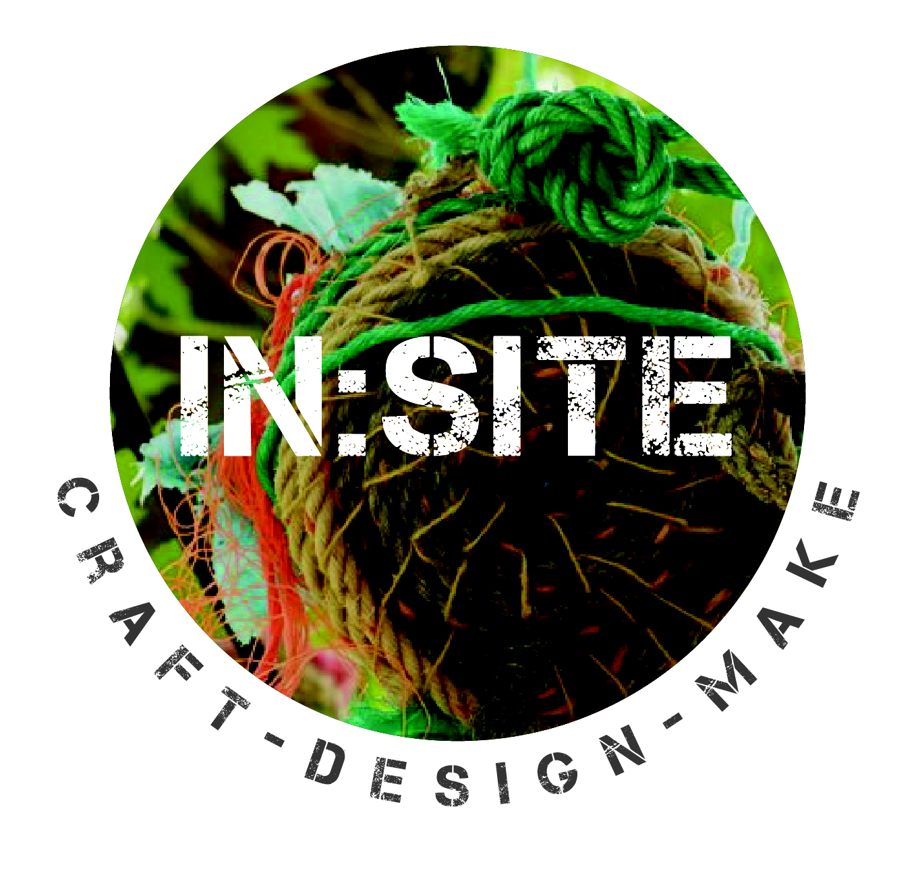

In:Site Volunteer Application 2019

About You
Name |  | Are you over 18?
Address |  | Postcode
Email |  | Phone

Please tell us which volunteer role(s) you are interested in?
Role | Description (summary of duties) | Skills and Knowledge | Rank
Event  Team Member | Working with participating artist/makers and general public.  Assisting the artist in the making and delivery of their work.  Assisting with workshops for the public including organising and preparing materials, setting up and clearing away Capturing data including feedback from the artists and public about the event and number of people. | Confident working with a diverse public  Communication skills  Interest in craft and making  Interpersonal skills  Organised, flexible
Photographer | Visual photographic documention of the festival including making processes, final pieces and public interaction | Photography skills to capture making and wider public engagement (where approved)

At which times can you volunteer at In:Site?
(please tick which sessions you can attend) | Thursday | Friday | Saturday
AM 10.30pm – 2.00pm
PM 2.00pm – 6.00pm

Are you able to attend the volunteer briefing meeting on Wednesday 28th August at 11am? (please highlight) Yes No
Why are you interested in participating and what skills and/or experience can you bring to the role?

Are there any particular tasks you would like to complete or gain experience of?

Access
Craftspace welcomes applications from all sections of the community and will consider making reasonable adjustments to enable people to work effectively with us. Volunteering at In:Site may involve some heavy lifting. If you have access needs please indicate your requirements.

Referee
Please provide contact details of your most recent employer or education institution.
Name of  Referee | Job Title | Address | Telephone/email

Signature

Signed: | Date:

Please send this form to: email info@craftspace.co.uk or post to Administrative Assistant, Craftspace, 15 Highgate Craft Centre, 8 Highgate Square, Birmingham, B12 0DU by Sunday 11th August. Thank you
Volunteer Opportunities

In:Site 2019
5 — 7 September

Looking for a new challenge?
Interested in craft, arts and participation?

In:Site is an annual festival showing contemporary craft made by graduate makers. If you are interested in joining a friendly team, would like to build your CV and develop your voluntary work experience, please complete an application form by 11th August 2019. You can apply for the following roles:

Event Team Member
Are you interested in visual arts, enjoy making and working with the general public? Event Team Member will offer you an opportunity to work with newly graduated artists/makers, assisting with activities and supporting the daily preparation and running of the event.

Photographer
The role of photographer captures the making of contemporary craft installations, participatory sessions with the public and the general atmosphere of the event. They will create a digital visual record of the installations and participatory elements of the festival.

To find out more about the festival see www.insitefestival.craftspace.co.uk

Volunteer Terms and Conditions In:Site 2019
- Volunteers must be 18 years old or over by 31 August 2019 to apply for In:Site Festival.
- All volunteer staff are required to familiarise themselves with and follow the code of conduct.
- Volunteers must be available at the times they have indicated in their application.
- Volunteers must be familiar with the Risk Assessment and the Safeguarding policy (this will be available onsite).
- Volunteers must read the information pack and be willing to attend a briefing session before volunteering at In:Site.
- Be responsible for their own safety and belongings.
- We will contribute towards local travel costs (West Midlands).

